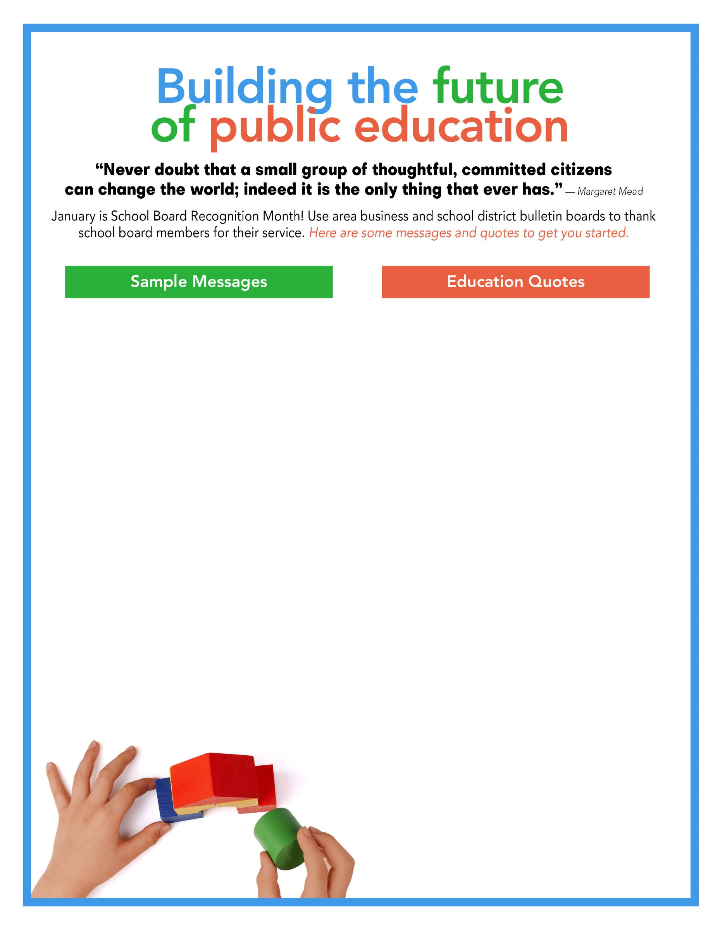
“The Public School is the cornerstone of a democratic society.”—Horace Mann

“Education is not preparation for life;
education is life itself.”—John Dewey

“An investment in knowledge pays the
best interest.” —Benjamin Franklin

“Education is not the filling of a pail, but
the lighting of a fire.” —William Butler Yeats

“The beautiful thing about learning is that no one can take it away from you.” —B.B. King

“I am still learning.”— Michelangelo

“The more that you read, the more
things you will know. The more that you
learn, the more places you’ll go.” ― Dr. Seuss

“Learning never exhausts the mind.”
― Leonardo da Vinci

“Learning is a treasure that will follow
its owner everywhere.” — Chinese Proverb

A mind, once stretched by a new idea, never regains its original dimensions.
—Oliver Wendell Holmes, Jr.

January is School Board Recognition Month
Say “Thank you!”
Helping kids soar to Success!
School Board Recognition Month
Superheroes for schools
Thank you, school board!
School boards make a powerful difference
School boards lead so students achieve
Positive, supportive, caring
Thank you, school board members!
Strong schools = Strong communities
Thank your school board
Leading students to success
____________ School Board
____________ School Board
Working to make a difference

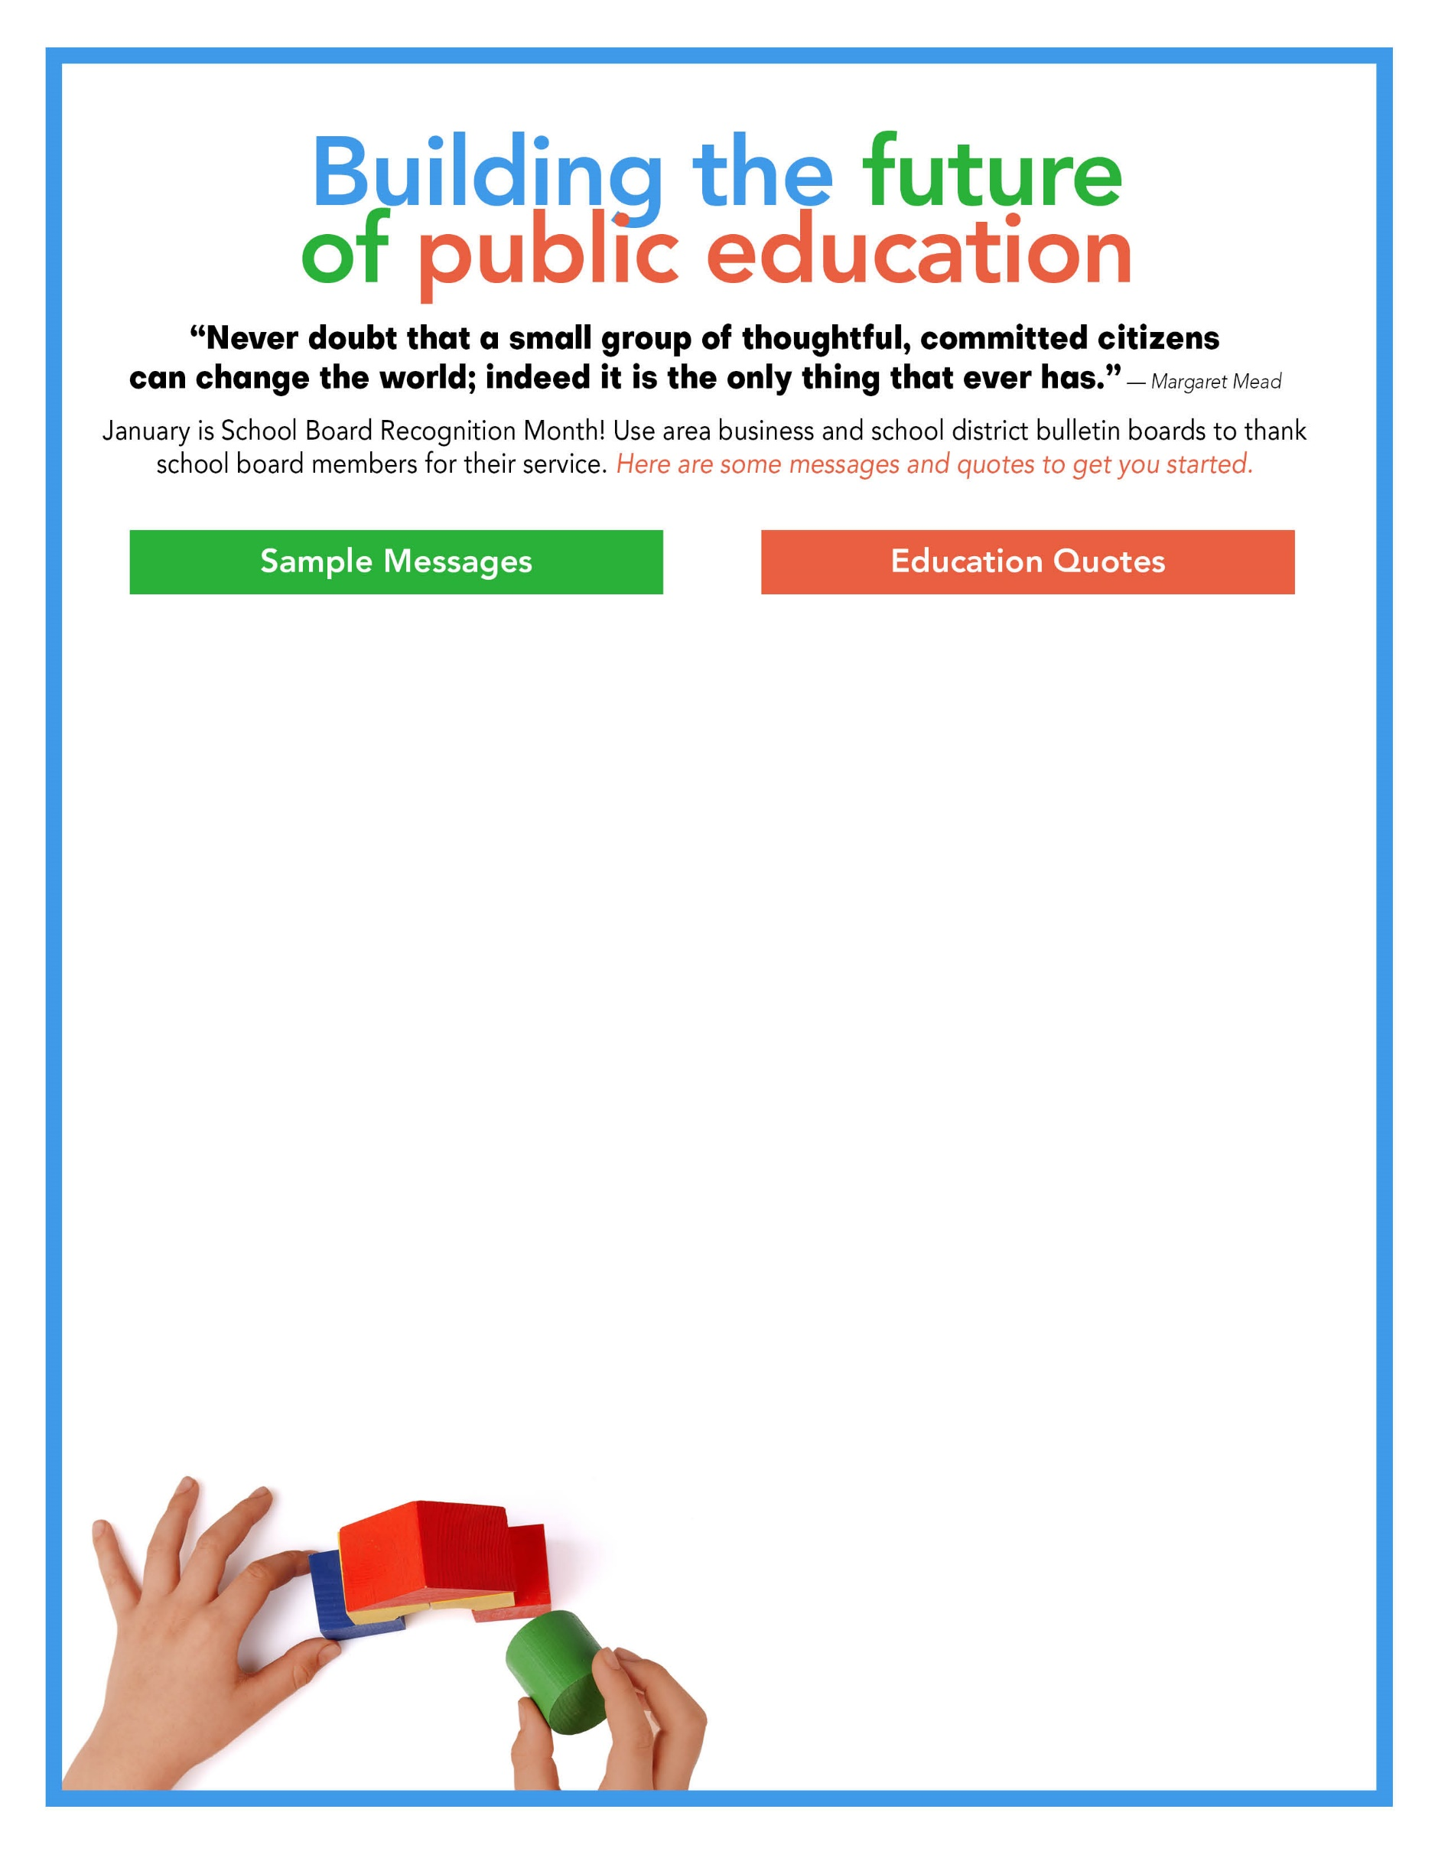
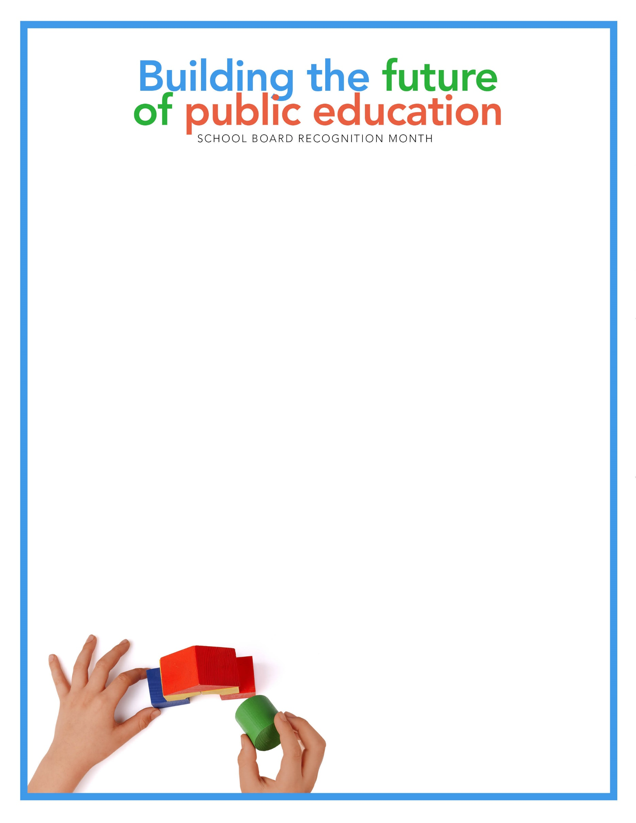

Insert your quote here

Insert your board’s photo here

